Create and Configure IBM services IOT Watson Platform

**Personal Assistance for Seniors Who Are Self-Reliant**

Team ID: PNT2022TMID19437 Date:10/11/2022

Step1: Log in your registered id

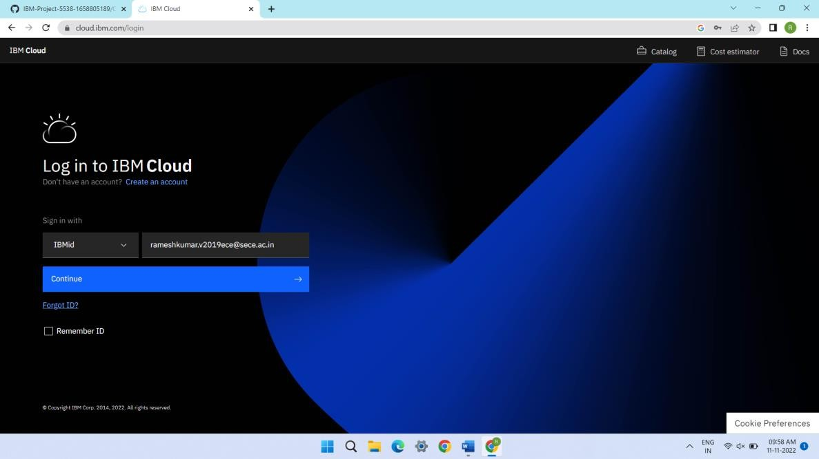

Step 2: click catalog where you find the services and internet of thing you can select and make location as London

Step 3: click create and the launch tab get open, then click launch

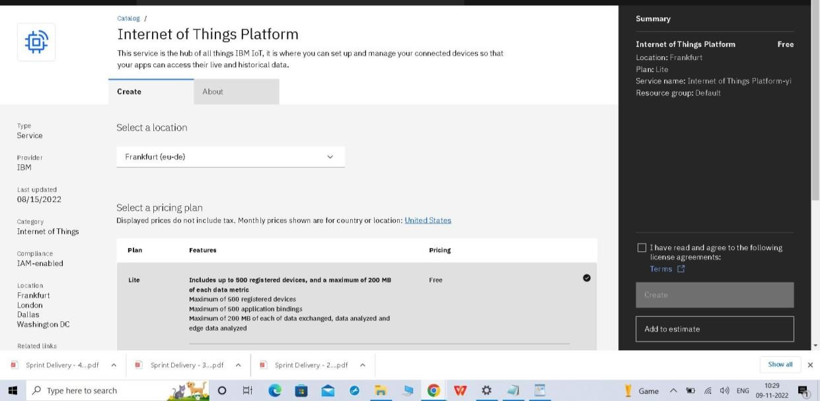

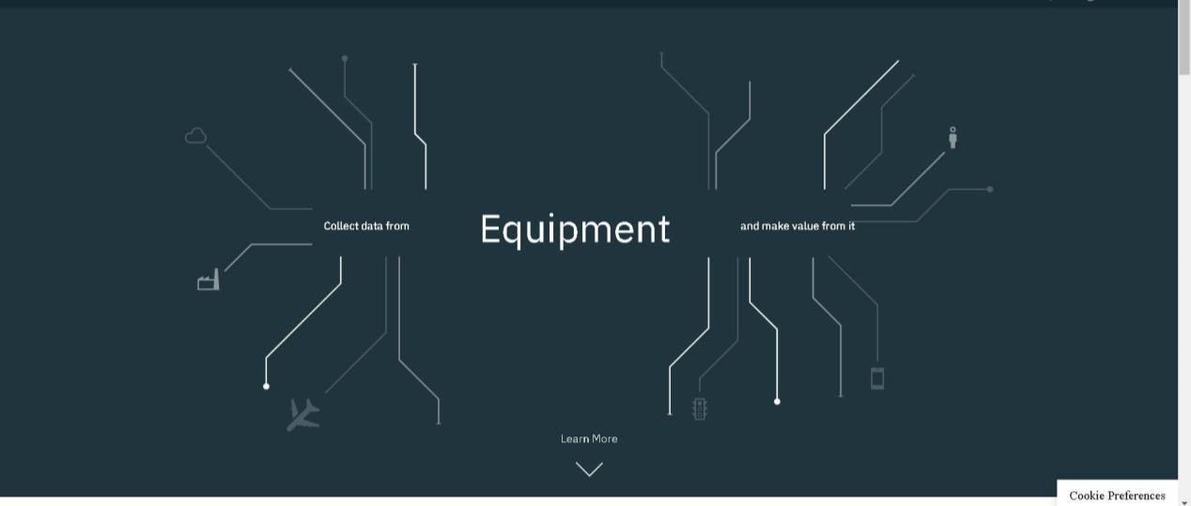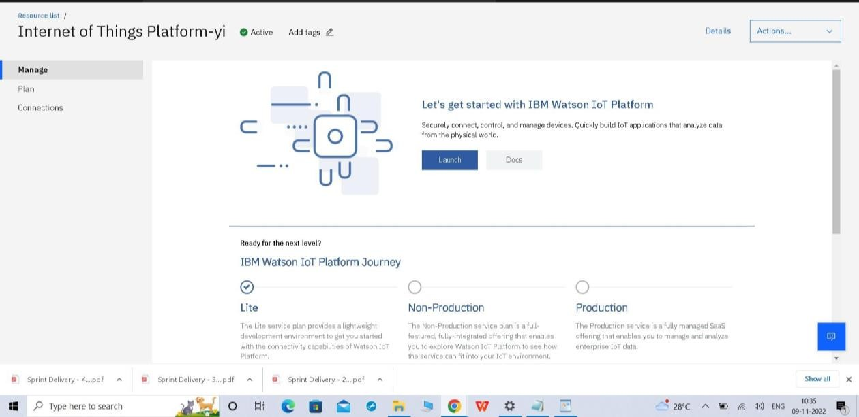

Step 4: It redirect you to IBM WATSON platform where you need to click sign in

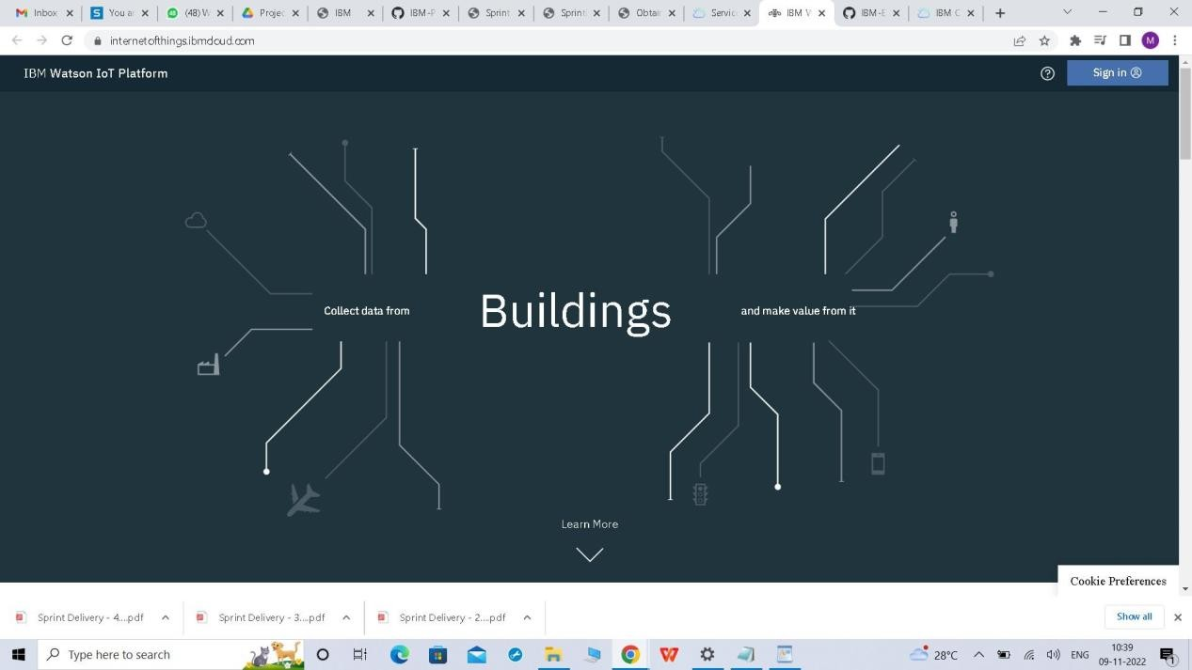

Step 5:log in with IBM ID

Step 6: where you find this tab which is used to add device , app, member ,usage , security can be worked

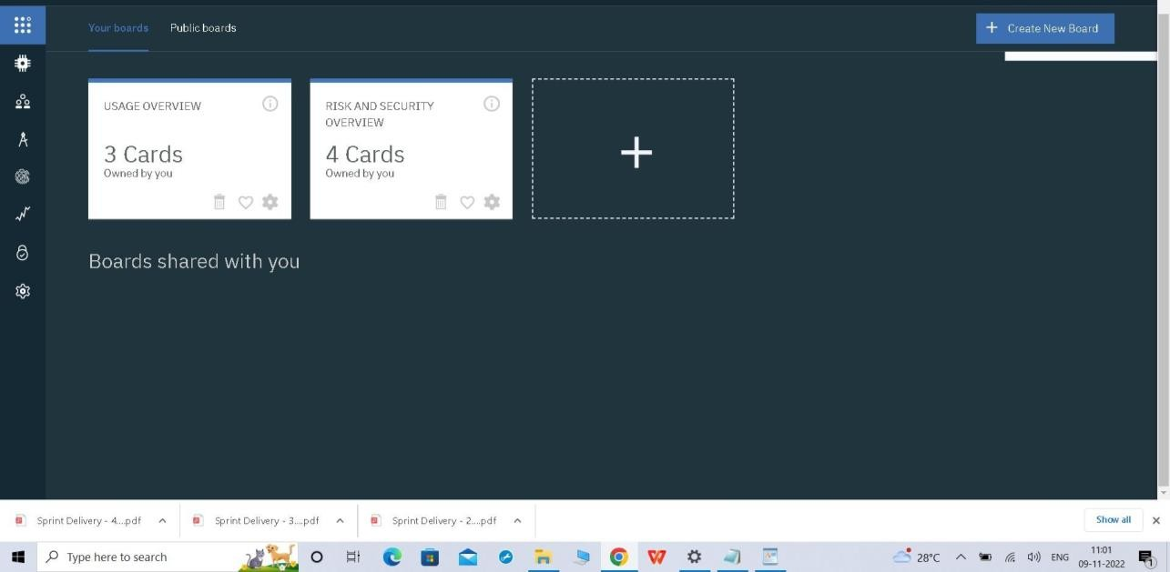

Step 7: check boards for risk and security overview card , it uses for graphical representation boards

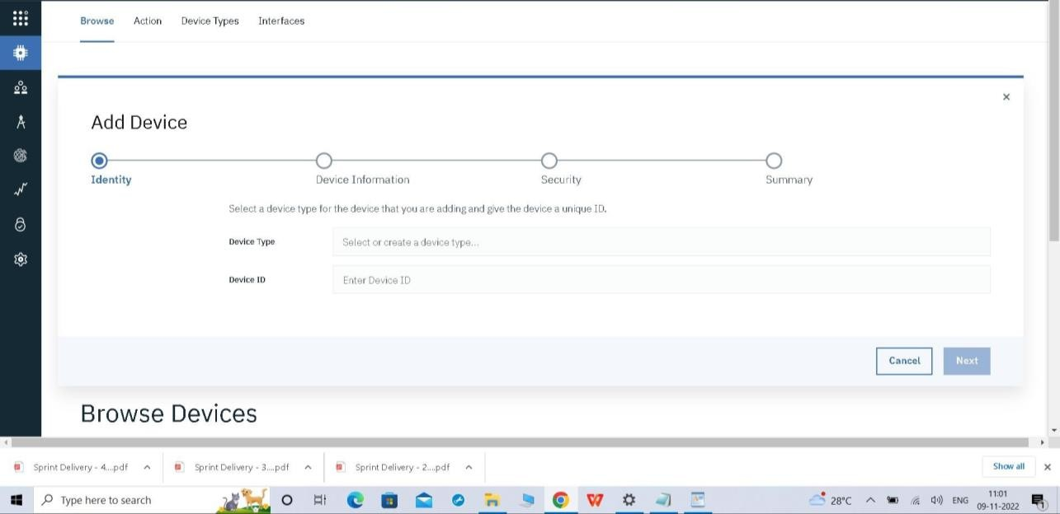

Step 8: after clicking create a new device / add device you can choose an device type and device id and complete the following information to create a device

